Danny Lambord – ICP-2005 – Report

Task 1

The title of the website that I am creating a design for is Rudgwick Country Show. The purpose of the website is to inform the user about the event and convince them to go to the event through showing them images of previous shows and explaining what the show is about.

User experience features that would be used within the website would be an image slider which would enable the user to look at images of previous shows therefore allowing them to be able to decide whether or not to go to the upcoming show. Another UX feature that the redesign would have is social media icons and the ability to check in to the event via the website this allows for the user to feel involved with the event via the official social media websites.

A design feature that might be important to the website would be a feature which would allow the user to change the text on the website to large text, this is because after looking at images of the shows the target audience is older people. Therefore a larger text feature would be appropriate.

Task 2

● Colour scheme:

* The primary colour that I have chosen is a soft green (#12345F) I have chosen this colour as it provides a soft feel to the website, this makes the website inviting to the user. Through using green the colour reflects the colour of grass which is suitable with the event being held over multiple fields.
* Base colour
  + #B9D78F
  + Sample



Navbar

* Horizontal layout

Sit

Dolor

Ipsum

Lorem

Task 3

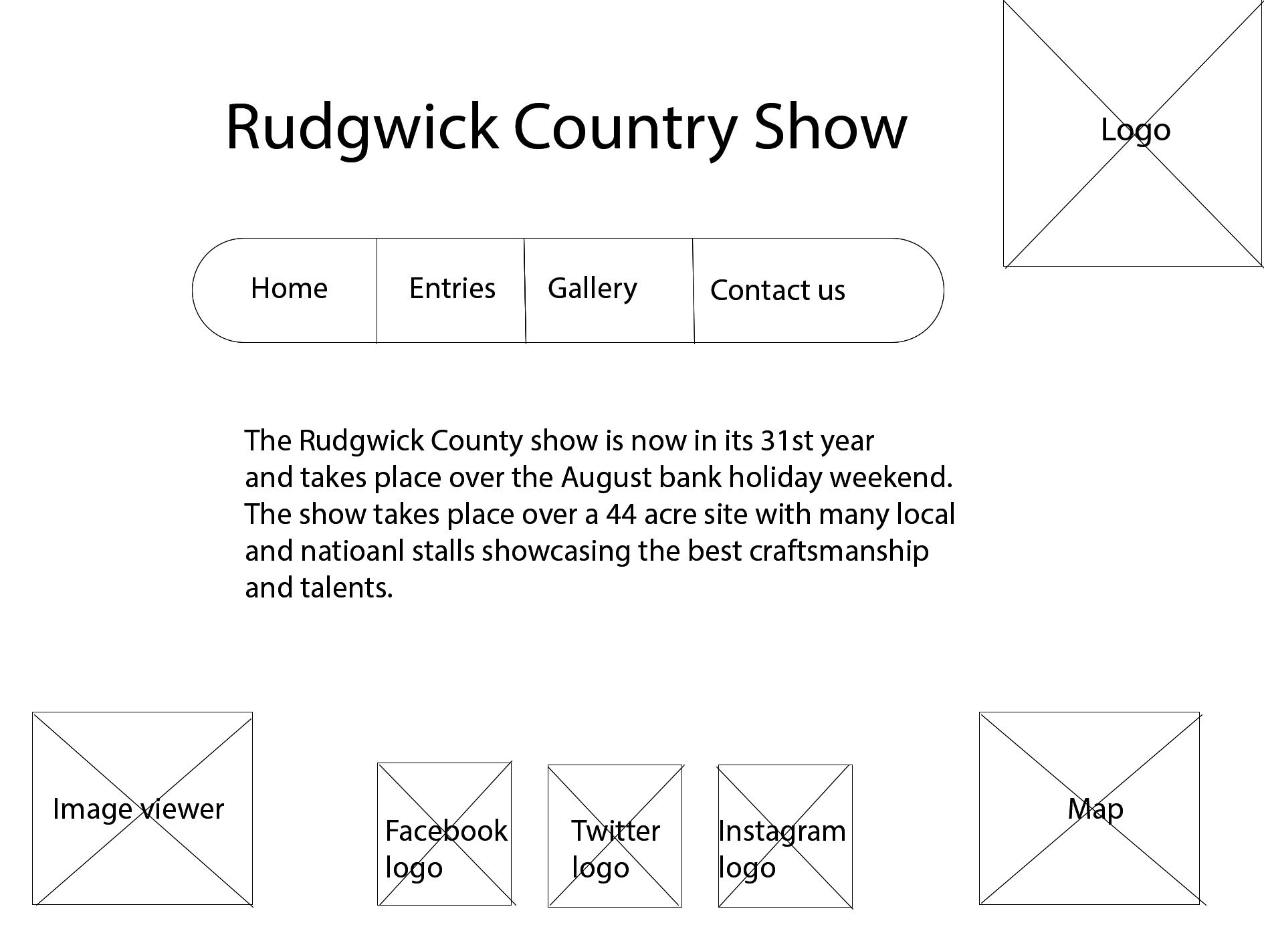

Task 4

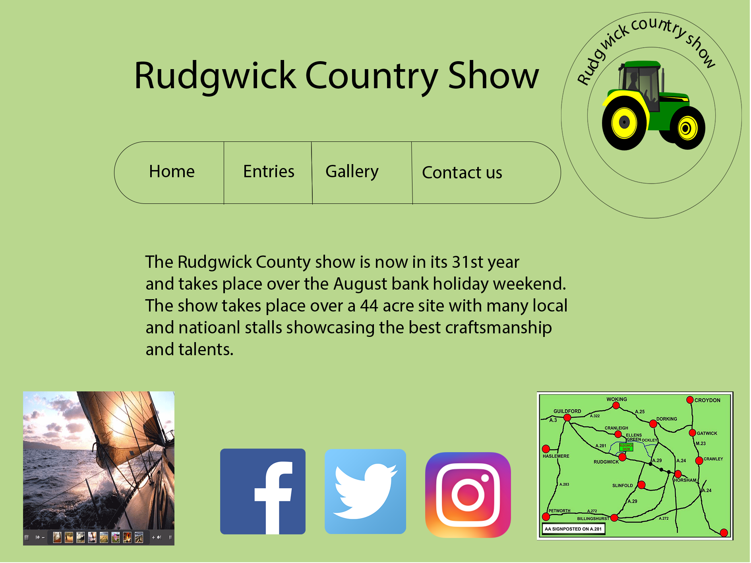

Task 5

In the first assignment I listed all the pros and cons of the website and critically evaluated the website. Through listing all of the pros and cons I was able to understand how the website could be improved by keeping the features that worked well, such as the image viewer. I was also able to look at features that could be removed or vastly improved in order to give the website a professional feel that would encourage the user of the website to go along to the event. One of these features was the navigation system which I have changed from being hyperlinks at the bottom of the webpage to a horizontal navigation bar situated at the top of the webpage.

In the second assignment I looked at the features that I said could be improved and the features that worked well. I chose the features that I thought worked well and included them on the features list on my first design sheet along with new features that I believed would be useful for the website. Throughout designing potential webpages for the website I constantly looked at how different features could be incorporated into different designs making each design unique, through doing this it allowed me to create a truly unique final design which would encourage the user to go to the event.

When creating the final design using Photoshop I was constantly looking over all of the five design sheets as this allowed me to see how a feature was before it was improved to go onto the final design, as well as looking back at all the sheets to ensure that the correct product was produced I created colour palettes as well as a wireframe design in order to give me a template when creating the webpage.

Through producing this webpage, I have improved my Photoshop skills which when I was starting this project was very poor, through doing the redesign using Photoshop I have been able to dramatically improve my skills within Photoshop. I have also been able to improve my design skills through looking at what features work well within a website and either improve on these features or keep them without any changes being made.